Digital Broker Photography Training: An Instructional Product Evaluation

Jonathan Weston

Purdue University – EDCI577

**EVALUATION PLAN EXECUTIVE SUMMARY**

**TO:** JON “POPEYE” JONES, CEO

**FROM:** JONATHAN WESTON

**SUBJECT:** EVALUATION PLAN FOR DIGITAL PHOTOGRAPHY FUNDAMENTAL eLEARNING COURSE

**DATE:** 10/15/2016

**CC:** OLIVE OIL JONES; WIMPY WAMBURGER

DISCUSSION OF NEED

As your online yacht brokerage, Hot Yachts, has been recognized for being one of the leading online brokerages in the world, this success has been built upon the realization that when it comes to building your online brand, image is everything. Knowing that time and budget are key factors to the success and overall branding image for Hot Yachts, your innovative plan to turn agents into photographers for your website was progressive. To go one step higher, you have also decided to utilize the agents as videographers for your online video programming, Hot Yachts TV.

Knowing that time and budget are key factors to the success of your well-laid plans, your programming, and the overall branding image for Hot Yachts, you found it necessary to disrupt the status quo of hiring professional photographers at a high cost. Depending on a photographer to be on site when optimal weather conditions prevailed was as well a hit or missed opportunity. With the agents frequently on site they could take advantage of these weather windows.

In searching for the best solution, you have decided to train your agents to be instrumental in this plan, turning them into able photographers and video documentarians. To achieve this goal, you have gone through several training programs before seeing the value in Nik Canon’s Digital Photography Fundamentals online training. They promise to engage the learner through multiple paths of learning designed to teach the basic fundamentals of camera operation, composition, and lighting.

TRAINING PLAN

Utilizing adult learning principles (andragogy), it is assumed that the agents are eager to learn how to use the new Digital Single Lens Reflex (DSLR) cameras provided to them. To date, the agents would typically throw the camera on Auto, and photography the yacht simply sitting at the dock. While the results were greatly improved, they still did not level with HY lofty goals of becoming the premiere online yacht brokerage, competing with Brutus Yachts International.

As previous programs were too difficult or did not offer enough mentoring support, Nik Canon has promised to keep agents enthused, informed, and glued to the program to fruition. With an 8 module-based program focusing on the most important facets of photography, the program will build weekly upon the knowledge base until they have reached advanced operational and compositional comfort in the use of their cameras.

OBJECTIVE FOR EVALUATION

After reviewing previous meeting and planning notes, the following objective was created for the seminar: “Increase the image capture skills of the agents to meet the standards of published yachting photography. The images obtained should not only exhibit excellence, but convey the yachting lifestyle.”

SUMMARY OF EVALUATION PLAN

Weston & Associates will utilize the foundations of Kirkpatrick/Philip’s evaluation framework derived and tailored to asynchronous (online) learning. Using five levels of evaluation, which we will describe in detail, the evaluation will address the following:

* Level 1: Agent/learner satisfaction
* Level 2: Training absorption (Did the learning stick?)
* Level 3: Application of training
* Level 4: Training impact (Are the agents still with us?)
* Level 5: ROI

KEY FINDINGS

The delivery of training is currently scheduled during the winter months when agents are least busy. As Level 3 and 4 evaluations will need a period of time for results to evolve, there will be a three month lag period before these can take place. Therefore we will present our findings in two scheduled meetings, as outlined in the Gantt Chart appendix. This will make it easier to base your decisions on whether to invest more into tailoring the program towards yachting photography, delivering the program to another group of agents, or eliminating/finding another avenue for training.

RECOMMENDATIONS

Some possible recommendations may include the following:

* Lengthening or shortening the modules to improve the overall learning results depending on discovered prior knowledge/levels of photographic expertise.
* Tailoring the program specifically towards yachting photography.
* Including regionally based live on the water photography seminars with and expert for hands on training.

Thank you for allowing Weston & Associates the opportunity to create and develop this important evaluation plan. We promise to ensure that this program has lived up to its promises, and delivers the return on investment desired. This includes retaining agents, elevating their photography skills to an acceptable level for publication, and saving money/time by not having to rely on professional photographers.

**Instructional Product Overview: *Digital Yacht Broker Photography Training***

Nik Canon breaks his Digital Photography Fundamentals training into [eight modules](https://canvas.instructure.com/courses/1028666/modules), each representing a basic yet critical function of camera operation. Through mastering these modules, the learner is expected to be able to create well-composed, properly exposed, luxury yacht in motion imagery. Each module is comprised of watching videos, reading linked articles, and taking knowledge checks before sending the learner out on a weekly assignment to apply the new skill. The resulting week’s photographs are uploaded to an online portfolio for instructor critiquing and discussion amongst participants.

Nikhas offered to tailor the instruction specifically to yachting photography for a fee, however Hot Yachts would like to first review the results of the evaluation from the standard training package, delivered on the Canvas Learning Management System. The course would have to not only be engaging, but also manifest the necessary skills and knowledge. Perhaps two courses might need designing. The evaluation will determine if there is a need to not only customize the training to yachting photography, but to the expertise level of the learner. Will the training bring enthusiasm to the agents and drive them towards competency?

Table 1 provides an overview of the instructional content provided within the *Digital Photography Fundamentals* learning module.

|  |
| --- |
| **Modules 1-8** |
| |  |  | | --- | --- | | [Lesson 1: Course Introduction to Camera Modes](https://canvas.instructure.com/courses/1028666/assignments/4787709) | Introduction to the camera controls for mode operations. | | [Lesson 2: Aperture and the X Factor](https://canvas.instructure.com/courses/1028666/assignments/4787711) | Light values and exposure compensation. | | [Lesson 3: Capturing Motion (Shutter Speeds)](https://canvas.instructure.com/courses/1028666/assignments/4787760) | Giving motion and the appearance of speed through use of shutter. | | [Lesson 4: Manual Mode, Isolating ISO](https://canvas.instructure.com/courses/1028666/assignments/4787762) | Completing the exposure triangle with manual mode and ISO. | | [Lesson 5: Lens Choice and Composition](https://canvas.instructure.com/courses/1028666/assignments/4787763) | Choosing the right lens for impact. | | [Lesson 6: Working with Natural Light, Flash and White Balance](https://canvas.instructure.com/courses/1028666/assignments/4787764) | Using the available light, fill flash, lighting and correcting color inside the camera. | | [Lesson 7: Working with Water, Polarizers](https://canvas.instructure.com/courses/1028666/assignments/4787766) | Front light, back light, controlling light with the Polarizer filter. | | [Lesson 8: Filters, Creativity, and Video](https://canvas.instructure.com/courses/1028666/assignments/4787768) | Other filters, creativity, and use of the DSLR video function. | |

*Table 1: Overview of Nik Canon’s Digital Photography Fundamentals course.*

Before paying for this course to be tailored, or even continuing to enroll more agents going forward, the investing stakeholders would like to first determine that the training significantly translates to superior yacht imagery. Is the 8-week curriculum schedule/content too lengthy or too short? How will the training address relevancies to yacht photography? Will the program retain agents, and bring more in, or send them away to competition. Most importantly, will they gain web hits and market share, thus making the company competitive with almighty Brutus? Weston & Associates will attempt to answer these important questions through the use of Kirkpatrick’s Four Level course evaluation.

**Audience & Context: *A Learner Analysis***

*Hot Yachts*’ internal company mission is: “To change the way people shop for yachts, using digital means of the highest quality, to romance luxury lifestyle.” Agents for Hot Yachts all work from home or boat offices. All training therefore, needs to be delivered online to the agent/learner void of any non-virtual face-to-face interaction with the instructor.

The demographics of the target audience are agents typically between the ages of 35-65, equally male and female, and English speaking – either as a first or second language. Learner agents are likely independent, highly motivated (working on commission), and social media savvy.

Most, but not all, are at a novice or iPhone skill level when it comes to digital photography. To address the disparity in skill levels, there are three personas for learners:

1. **Primary Audience:** A yacht broker agent, digital photography novice, who has little to no experience with photography other than taking photos with their smartphones or a consumer point and shoot. This type of user likely has reservations against learning an entirely new skill. They also have self-doubts about producing the type of imagery seen in most yachting publications.
2. **Secondary Audience:** A yacht broker agent, digital photography intermediate, who currently takes their own fairly decent photos of the yachts they represent with a low-end DSLR. However, their skills can be elevated to produce higher quality imagery, thus alluring their higher-end audience to purchase extravagant toys. This group will be interesting to evaluate, to see how they respond to perhaps some initial fall out of the *Vygotsky Zone,* a zone of psychological engagement where the learner finds the training to be “*in the zone*;” not too easy, nor too difficult.
3. **Control Group:** Although this group (10 agents) will utilize the advances in technology of their new DSLR cameras, they will not take the training; yet they will still be evaluated with the same Level 2 (Learning) Pre and Posttest evaluations/portfolios as the participants, to correctly level the appropriate assessment content. Weston & Associates will use this comparison group to measure against the gains in operational expertise and compositional eye of the experimental group (those taking the training), as there will be some certain immediate quality gains derived solely from the use of higher end cameras. . If there is a 10% gain in this group, then 10% gain should be discounted from the gain in both the primary and secondary audience group learners, so as not to attribute the training itself to the improvement. An evaluator would judge that the gain was derived from natural gain in familiarity of camera use and Rubric criteria knowledge.

**Measurement Instruments & Procedures: *An Evaluation Strategy***

The following evaluation strategy applies Level 1 and Level 2 evaluation methods from Kirkpatrick’s 4 Level Evaluation Model (Kirkpatrick & Kirkpatrick, 2006). Level 3 and Level 4 evaluation methods should be incorporated 3 months in the future as a part of a more expansive evaluation plan.

***Level 1 Evaluation:*** Due to the high dropout rate of previous training modules delivered asynchronously by NYU Photography School and the ineffectiveness of Lynda.com, it is essential to conduct a Level 1 evaluation instrument to measure the engagement success of Nik’s Digital Photography Fundamentals course. The learner agent must be satisfied with the training, feeling it well worth their valuable time. The training nor evaluation must not be too easy nor difficult; instead achieving a level of engagement that holds their interest throughout. As every learner absorbs information differently, the Level 1 evaluation will also address the variety of learning approaches. In the end, do the agents feel that the training was not only worth their time, but helps them reach their goal of providing rich, enticing yacht imagery for online advertisements?

* *Evaluation Instrument:* Three required survey questions embedded into 8 Canvas Lesson [Assignments](https://canvas.instructure.com/courses/1028666/assignments/4787711?module_item_id=9890210) will follow each module to be answered by each participant. They can also be accessed through the [Quizzes tab.](https://canvas.instructure.com/courses/1028666/quizzes)
* *Evaluation Procedures:* These three questions each come from the three types of Level 1 evaluation inquiry:
* Quality of content
* Relevance to current goals
* Overall learner satisfaction

With just three questions weekly, the participant should not feel rushed at the end of the course to complete the Level 1 evaluation. With this approach, they would not be running out the door, exhausted from the additional activity most courses require to complete. Therefore, the weekly answers should provide better quality feedback.

***Level 2 Evaluation:*** Measuring Level 2 learning outcomes translates the photography skills they have learned into up leveled imagery. Thus, placing before and after training imagery side by side will be a sound performance measurement.

* *Evaluation Instruments:* [Pre-test](https://canvas.instructure.com/courses/1028666/quizzes/1637276) and Initial Portfolio vs. [Post Portfolio](https://canvas.instructure.com/courses/1028666/assignments/4851474?module_item_id=9890231) and Post-test.
* *Evaluation Procedures:* Level 2 evaluation data should be collected during and after the learning process to ensure positive learning outcomes.

1. ***Pre-test:*** An online quiz (Appendix 1) comprised of basic photography questions, using comparative images (side by side photos showing different settings used to take the photos), will attempt to measure the start level skill of each learner agent. 10 questions comprised of multiple choice, true-false, and mix-match assessment will be delivered before the course commences. Each participant will only have one chance to take the test, as multiple attempts would not allow evaluators to judge competency. The learners will be given feedback explaining the correct answers, which is not necessary for evaluation purposes but will assist learners in beginning to grasp the assessed concepts.
2. ***Pre-Portfolio:*** The learners will also post their fifteen best yachting photos: Five interior, Five exterior at dock, and Five sailing in motion. This will measure the learner’s starting point and prior knowledge, which will also assist the training designer target learning towards future audiences (if the training proves successful enough to continue).
3. ***Post-Portfolio Performance Assessment:*** A [Rubric](https://canvas.instructure.com/courses/1028666/assignments/4851474?module_item_id=9890231) (grading guideline, Appendix 2) will comprise the assessment tool used to measure learning gained from the course, of a Portfolio comprising as well: Five interior, Five exterior at dock, and Five sailing in motion photographs. These can be photographs taken at any time during the course to represent the best examples captured, though most likely they will be photographs taken near the end of the eight-week term. Results will be measured against the pre-portfolio.

***4. Post-test:***  An engaging Game Show, which is essentially a multiple choice quiz placed

in a gamification format, will become available to participants in Week 8. This test will award them each 10 points, regardless of how they perform on the test, as it is only meant

to be an incentive to take the evaluation instrument. Results will be measured against the

pre-test.

***Level 3 Evaluation:*** Level 3 measures how well the Level 2 learning outcomes are set into practice. How did the lessons stick? Three months will pass after the training before the Level 3 video surveys take place. This will allow enough time to pass for the agents to sign up new clients, photograph their yachts, and submit them to Hot Yachts HQ. From here, the photographs will be evaluated with a set of criteria by the artful eye of Hot Yachts’ photo editors. They are the ones crafting the marketing packages together; therefore objectively striving to maintain a high level of image competence for which the company has gained respect. They evaluation will correspond topically to the lessons, judging the level of expertise each agent has obtained since graduating from the training. An Excel graph will combine the results to measure how all three groups progressed at all three levels:

* Before training commenced
* After training concluded
* Three months after training

Weston & Associates specializes in compositing video testimonials for presentation impact, so the agents will respond to Level 3 questions on video. As the agents have video capability on their DSLR cameras, the interviews can be self-imposed through answering a provided list of survey questions.

* Are you using the new cameras they way they were taught or are you still falling back on auto features?
* Has taking your own photographs created enthusiasm for your career or is it interfering with your duties to perform sales tasks?
* Do you feel that you need more training?
* How often do you resort to paying for professional photography?
* Overall, to what extent has the training impacted your agency work?

These videos will be edited and composed into one video, as well as transcribed and transposed to a Likert scale 1-5; a score of one for not applied to five for complete transfer of skills.

***Level 4 Evaluation:*** Measuring Level 4 learning outcomes, return on investment (ROI), can be the most difficult to measure in any training scenario; this level is often omitted. With so many outside variables influencing ROI, an evaluator can’t blame the training for economic downtrends nor credit for economic gains. Competition and an evolving business model can also be factors to consider. In the yachting business, even a bad hurricane season can affect your bottom line. But if there is an economic uptick, and your bottom line is sinking, you can’t blame it on the storm, economic or physical. The fault could lie in your business model, or as this evaluation hopes to disprove, the prescribed training.

To blame or credit your training, you would need to properly evaluate your ROI. This could be done in two ways: A) Evaluate the agent on the impact taking photography into their own hands has had on their business. B) Evaluate the buyer on the impact photography has had on their buying decision.

Since you have to consider the variable discussed in Level 3 evaluation that each agent is different, we have decided to weigh more heavily on:

**B**, *evaluate the buyer*. Using the Likert scale of 1-5, we plan to ask the agents to evaluate their purchase decision-making process. How much did marketing influence their decision? Did photography play a part in enticing them to make their purchase? If photography, was it the photos of the docked yacht, the interior photos, or the yacht under sail that enticed their wallet?

You could also relate business impact to audience. This data is simple to evaluate: How many hits have been garnished or lost since Hot Yachts implemented the Platinum package training plan?

How many agents have they gained or lost? This retention data will also come from HY HQ. Retention is a telling business factor, as without the agents, the business would as well fold.

So most importantly, we must address:

**A**, evaluate the agents. They will be delivered a survey three months after training to understand whether they have become more enthused through becoming greatly involved in the process; more than just a salesperson. Or, do they feel that the extra task of being a photographer has impacted their focus on sales. The evaluation has to look closely at these results, to witness if those that exhibited greater photography skills answer one way, whereas those with less would prefer to focus on sales. Due to the complexity of answers that go beyond the Likert scale, the agents will again ask these questions to themselves. A sample of Level 4 interview questions can be found in the Appendix section.

Note: Some Level 4 evaluations are also delivered after one year has passed, however HY is pressed for time to make crucial decisions which will impact their objective of selling more yachts and retaining the best agents; a goal which depends on the best training available.

**Level 1-4 Reporting: *From Data Collection to Analysis***

The information collected in Levels 1-3 provides valuable insight into the development of instruction – from a learner reaction, learning outcomes, and career relevancy perspective. The conglomerated results can also be used to determine the value of the program, but it is Level 4, added business value, which Hot Yachts is most concerned. However, all four levels have causal relationships to one another, so each one must be examined and considered. Is Hot Yachts risking its reputation by continuing with this progressive training and marketing plan, or are they charting a solid course for business success? Let’s take a close look at the potential reports, breaking them down level by level.

Though some photographic knowledge and discerning eye is required to evaluate the gains in learning, it is expected that the photographs will show marked improvement to most anyone’s eye that have been exposed to luxury media. As well, the *Primary* audience should see greater gains than the *Secondary* audience, and both more improvement than the *Control* group. It is the purpose of this evaluation to not only prove these increased levels of artistic achievement, but to provide an analysis lens to the relevance of training, engagement, timeliness, and overall satisfaction of the course.

***Level 1 Reporting:*** The Digital Photography Training Level 1 Survey has 24 questions, most ranging from too simple to too difficult, divided equally into each of the eight modules. Due to the experimental sample size, fewer than 30 participants, it should not be overly time consuming for Weston Consulting to aggregate this data. There also exist some essay type questions allowing the participant to respond in their own words, which should give a deeper understanding of motivation and content. Throwing out the low and high evaluations, both samples should aggregate to give an accurate picture of how effective the training has been, from a Level 1 user **satisfaction** perspective.

***Level 2 Reporting:*** Measurement of **relevant** learning will take more time and a more educated grasp of content knowledge to gauge. Nik Canon’s training company has agreed to do a pre-evaluation of each learner, as the Pre-Test and Portfolio comprise an integral course component. More than anything, the resulting portfolios should speak volumes toward the effectiveness of the course **content**, and serve as the most telling proof of accomplishment. Other questions answered will be the division or shortening of the course for those coming in with prior expertise (Secondary audience), and any other improvements that can be determined from the evaluation. If in the end, if the resulting photographs show marked improvement to a level presentable for the discerning yachting audience, this alone will hallmark the training’s success; thus pave a road to Level 3 and Level 4’s success as well.

***Level 3 Reporting:*** As outlined previously, Level 3 reporting will be done with graphs from the HY Design Team feedback judging the level of expertise achieved and applied to the job, evidenced by the photographs submitted to the agency for actual web integration.

The Level 3 agent feedback video report will be the most time intensive evaluation, as the videos will be transcribed and translated into quantitative data, breaking down the responses into a Likert 1-5 scale synopsis. The mean message derived from the videos will be crafted into a convincing, yet unbiased presentation, editing out the most favorable, and most negative responses. This aims to give an accurate, common voice to the evaluation.

Note: It is expected that each participant may view the training differently, reflecting their income level and sales goals. It is predicted that some of the higher earning agents will not apply the learning to their brokerage practices, instead continue their practice of hiring professional yacht photographers; focusing their own efforts entirely on sales. A decision could be made to exempt these agents at a certain income level, and the Level 3 data obtained will decipher at just what income line this should be drawn. But this is all guesswork without the Level 3 evaluations, which should offer solid evidence. It could very well be that the more successful agents enjoy the photographic process, and those on the lower income scale are the ones that need more time to focus on sales. For these very reasons we perform the evaluation.

***Level 4 Reporting:*** Level 4 has often been split into Levels 4 and 5 per the Kirkpatrick/Philips model – 4 being significant measures of impact on business, and 5, ROI. The measurement of Level 4 is simpler in this case, because an evaluator can point quantitatively to the number of agents that dropped from the program due to agents falling out of the “Vygotsky Zone.” In other words, the training was too difficult or too easy – most likely too difficult. HY should be able to provide the statistics for this measurement, which will be graphed for demonstration.

The charting of Level 5 becomes more difficult to measure, but to simplify, we would need to again go back to part 2 of the objectives, part 1 being obtaining agents. The main objective is to beat Brutus. To do so, the imagery needs to evolve to a higher level, and agents need to provide quality programming that will bring a tour de force of social media, and in the end, relative hits to the website. But advancements in SEO could play a factor as well. In the very end, they need to sell more yachts. Just how much ROI does the CEO need to see? Using the Kirkpatrick/Philips ROI formula:

ROI = Net program benefits divided by Program cost multiplied by 100%, we can measure ROI simply with the difference in revenue being the program’s net from

So Level 5 will measure one thing, and that is the sale of yachts – before the training begins and again three months after the training ends. This will be presented in a simple graph.

Whether 3 months is enough time for those measurements to paint a truthful picture could be an unfair ROI measurement. Creating programming and gaining audience traction takes time. It has been suggested to the CEO that the time frame for measuring Level 4 (and 5) is too tight, and recommended extending to one year. However, the reporting is to be delivered three months after training ends, at which time Popeye will decide how well his company stacks up against Brutus at that time, and the ultimate decision will of course be made by Popeye (or some say, Olive Oil) on whether or not to extend the training.

# References:

Kirkpatrick, D. L., & Kirkpatrick, J. D. (2006). *Evaluating Training Programs.* San Francisco: Berrett-Koehler Publishers, Inc.

Bailey, Allen. (2014?) Retrieved from: http://www.busgurus.ca/media/pdf/the-kirkpatrick-phillips-evaluation-model-en.pdf

**Appendix 1, Level 1**

Three Level 1 evaluation questions, total of 24, are linked to each Lesson; shown here, Lesson 4. Access was given to access the actual links of all lessons and quizzes. These are listed in the lesson, in the Quizzes tab, and are of the Survey family. Participant agents do not see the answers, as they are only evaluations, but the answers are reported to the evaluator to data aggregate.

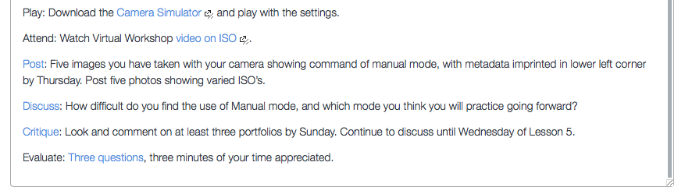

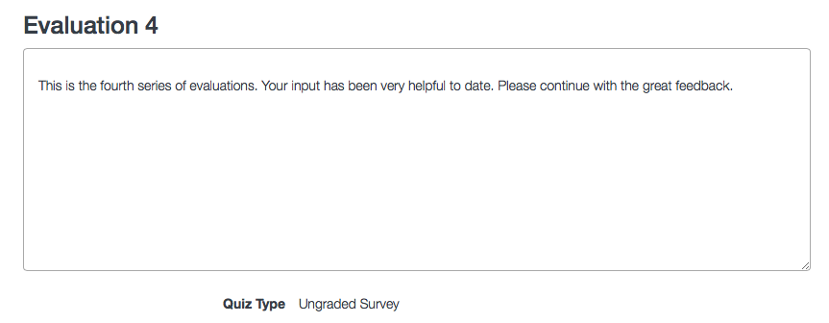

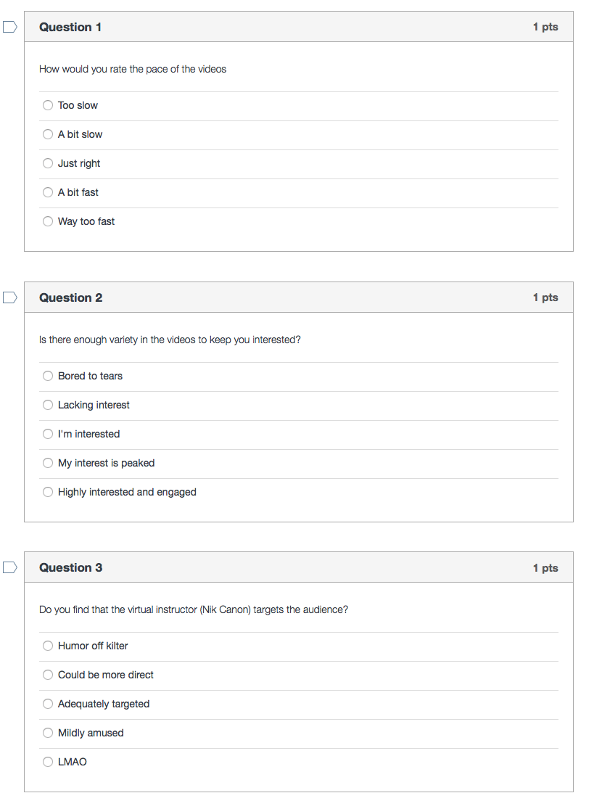

Appendix 2: Level 2 Pre-Test

The examples shown here are of the Pre-Test, which will attempt to gauge the learner’s prior knowledge of photography. They can only take the test once, as shown here, but the setting has been temporarily reset to take multiple attempts for those interested to take a trial test. The test is easily accessed through Modules–Module 1 or Quizzes tab.

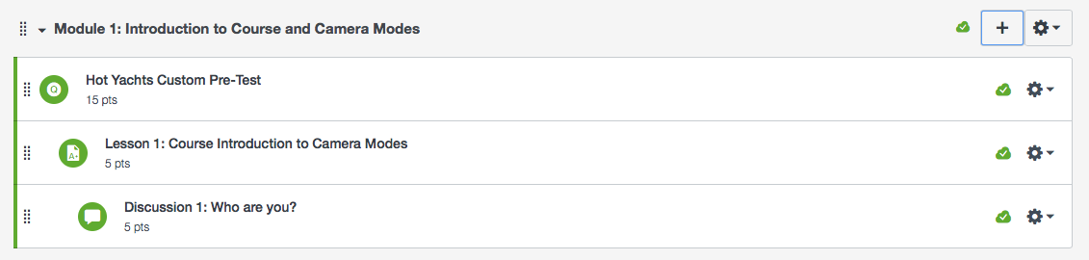

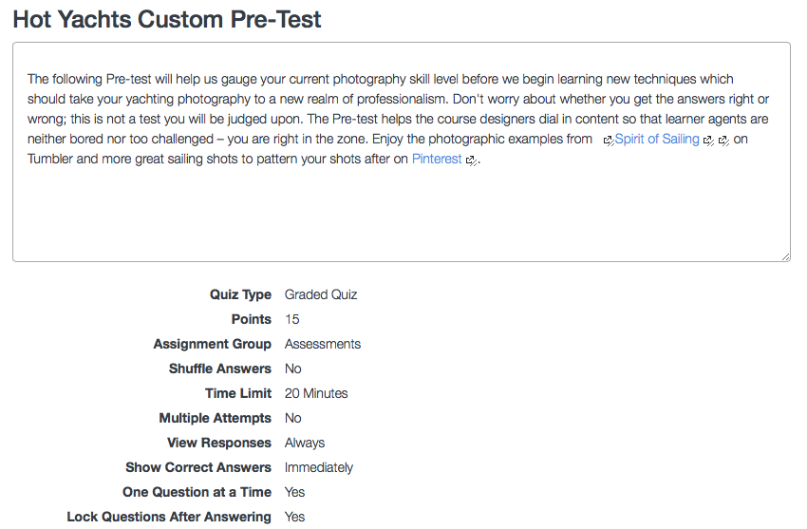

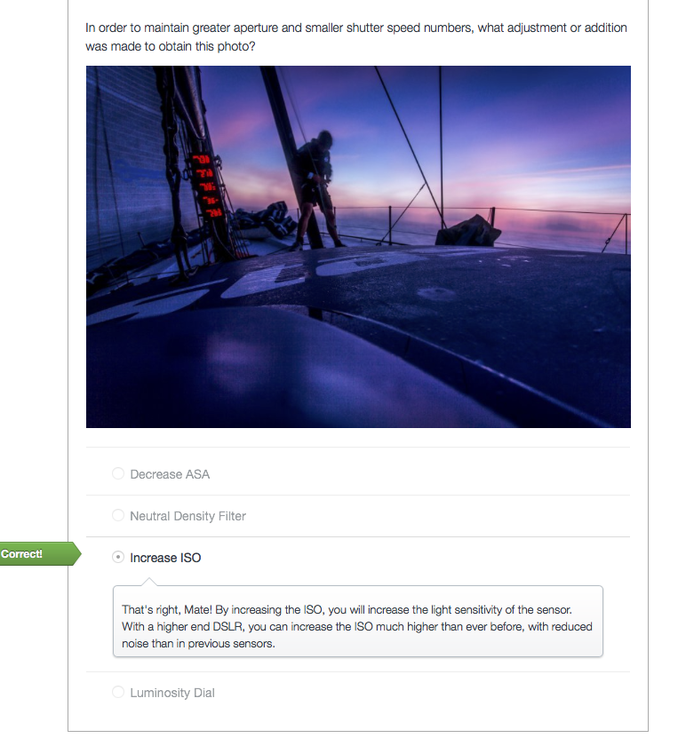

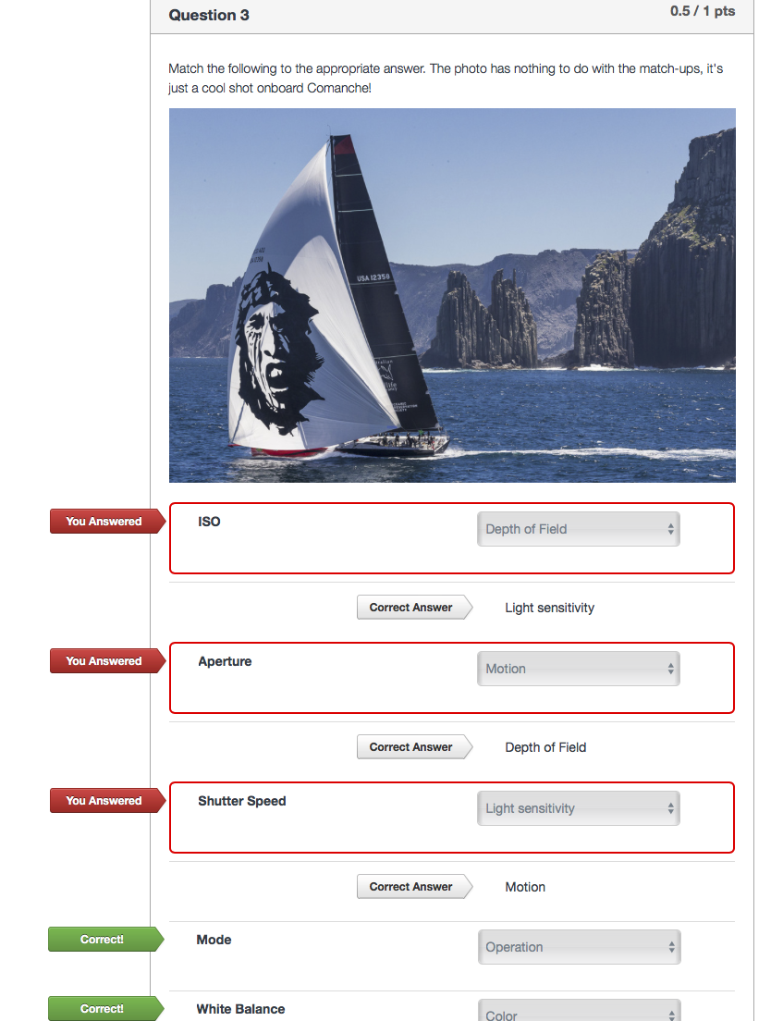

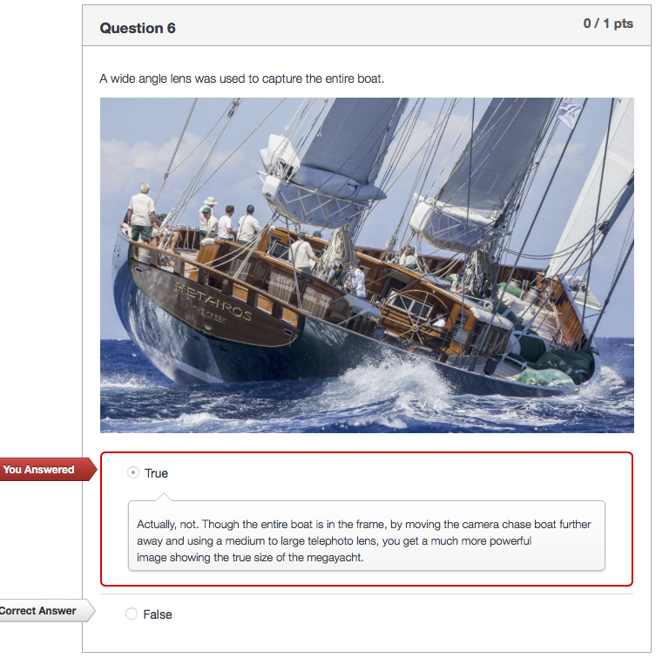

Appendix 3: Post-Test Performance Portfolio

The most telling picture will be the Portfolio, accessed as well through the course [Syllabus](https://canvas.instructure.com/courses/1028666/assignments/syllabus), and [Modules](https://canvas.instructure.com/courses/1028666/modules). The Rubric should guide the agent towards optimal performance.

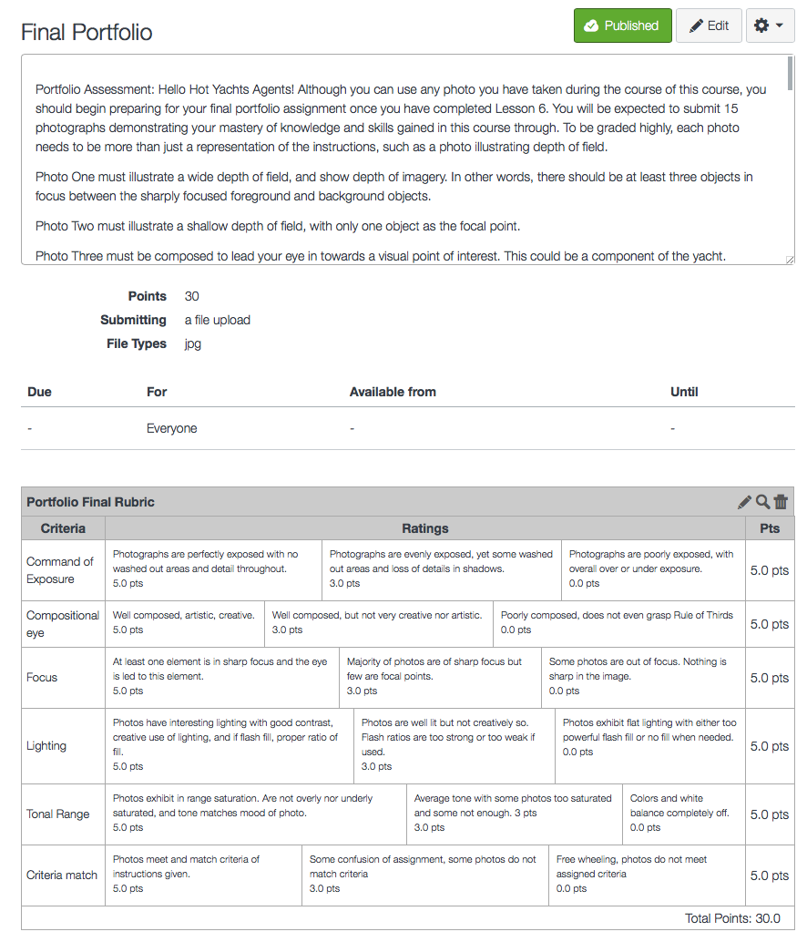

Appendix 4: This is the Post-Test Game Show, which can be accessed through [this link](https://canvas.instructure.com/courses/1028666/assignments/5341145). Following screen shots are examples of the game (but please play!):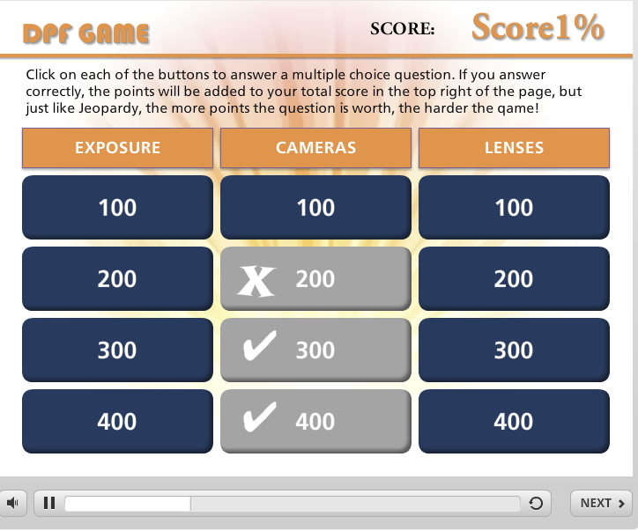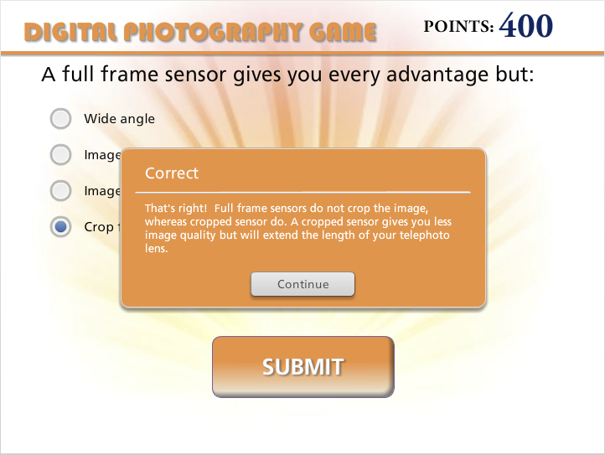

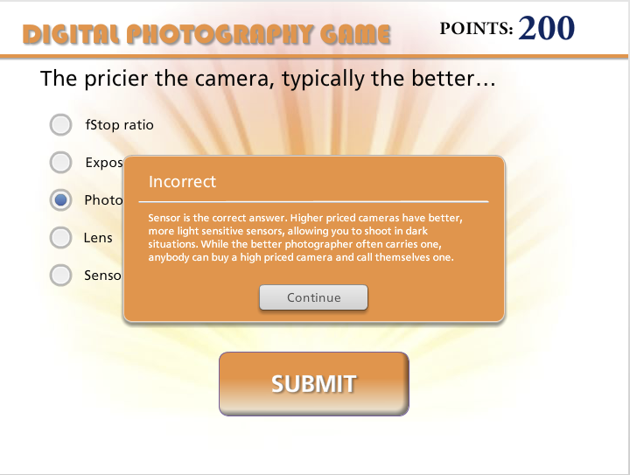

Appendix 5: The following Gantt Chart, composed in Smartsheets, outlines the project management details for this evaluation. Due to the lag time of three months from Level 2 until Level 3 evaluations, this chart is shown in two parts.

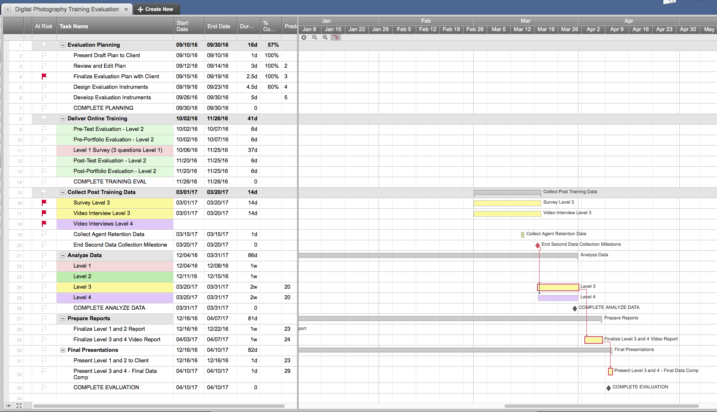

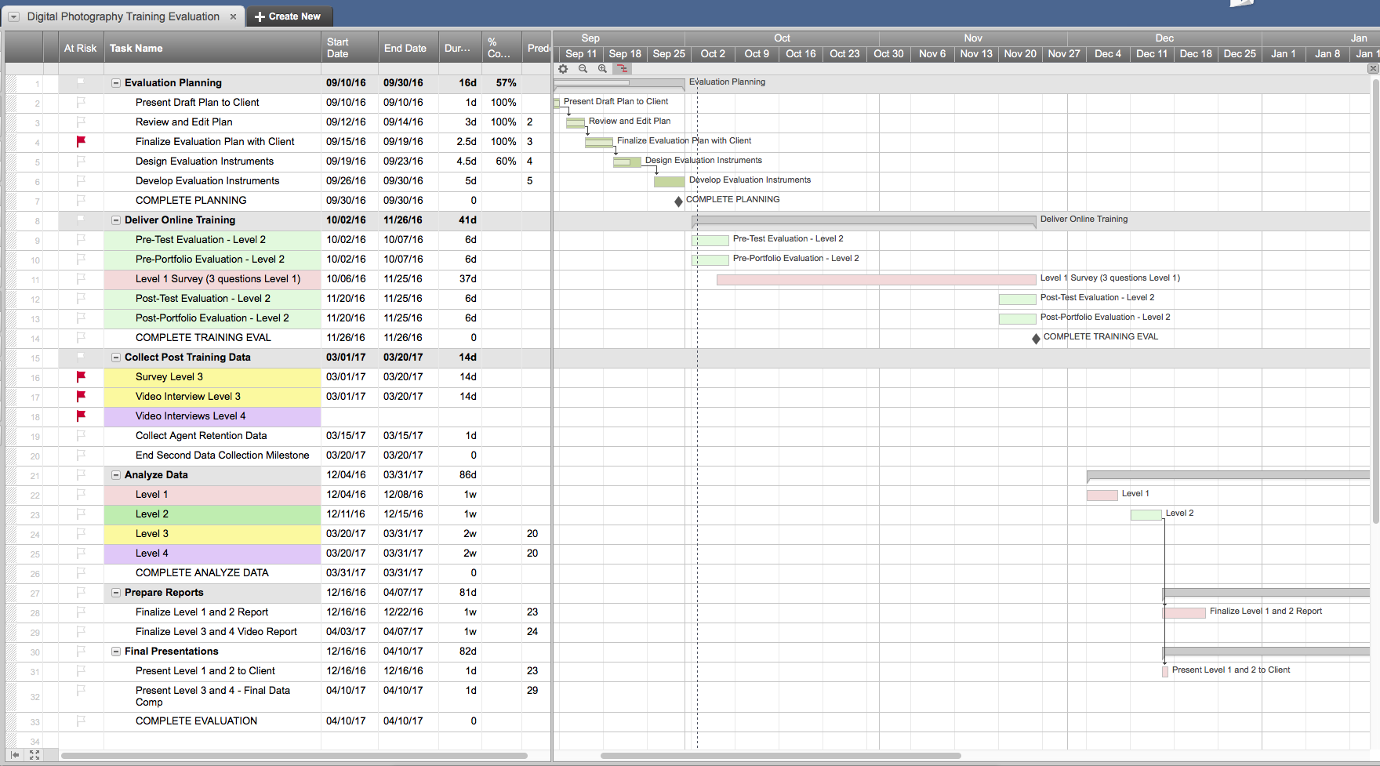

The evaluation will be presented to CEO Jones in two stages outlined in the Gantt chart. Levels 1 and Level 2 will be presented in the first phase, and Levels 3 and 4 after analyzing data and the three months lag period (signified by the pink line). Dependencies are marked with down arrows and milestones with diamond points. Thank you for viewing.