### Assignment #2: Paper Prototype Digital Photography Fundamentals Jonathan Weston

**Purdue University EDCI 569000**

**June 5, 2016**

**Dr. Walker**

# Table of Contents

Course Description 2

Target Learners 2

Learning Goal & Objectives 3

Why Constructivism? 4

Canvas LMS and Course Design 5

Lesson by Lesson Outline 5

LESSON 4 Storyboard 8

Merrill’s 5 Star Instructional Design Rating Evaluation 24

Type of Instruction 24

Assessment Examples 27

Bibliography 29

# Course Description

This course is designed to be an asynchronous, standalone e-learning course for people that want to learn how to take better photographs with their cameras but do not desire, are not geographically located, or have time to take a formal class of instruction. They have access to the overwhelming amount of information on the internet and in books, but need this information condensed and simplified. As well, they want personalized instruction and feedback from working professionals, and a regimented schedule requiring practice. They come from a past where boring lectures were the norm, and now live in a society where multimedia based learning has become vogue. Addressing this culture, the course will be delivered utilizing multimedia methodologies and principles.

Focusing on family, adventure sports, and travel photography, this is not a course to learn studio photography, but will provide the fundamentals necessary to advance from the course into studio photography. The course attempts to answer the big questions most budding photographers ask, such as what type of camera and which lenses to be buy for their desired photographic pursuits. With some degree of teaching targeted towards the understanding of basic compositional rules and lighting, the key takeaways are familiarity with camera controls. Camera operations will be performed in aperture and shutter priority modes, culminating with fluid working command in manual mode.

Digital Photography Fundamentals consists of eight modules, with key lectures delivered in an innovative video format. The innovative elements include not only 3D camera like simulations, but an animated fictional professor. Each video lecture also includes knowledge checks, with thorough explanation of answers, embedded within the presentation designed to build upon and reinforce Learner understanding of the presented material. Building upon the skills learned from the previous module, each Learner is expected to head out into the field and capture relevant examples to share with the class, creating a social learning environment on a Discussion Board within Canvas. They will also learn from live ‘chats’ with professional photographers, and be provided with specific links to key resources for further details and demonstrations. Tools assisting understanding of camera operation to obtain the perfect exposure are the DSLR camera simulator, as well as a Lens simulator to aid lens choice.

# Target Learners

This e-Learning course is for life learners, working or retired adults who don’t have the time nor inclination to attend a classroom course or the confidence yet to attend an expensive workshop. The target age of the Learner is between 30-65 years old, an age typical of a continuing education adult responsible enough to follow through with lessons and engage responsibly in an online social environment. Learners must bring their own motivation as there is no credit for the course other than crediting yourself for becoming a better photographer.

This course requires access to a computer with hi-speed Internet and a card reader to view and interact with the Instructor and other students in the course. Learners must own a

basic DSLR camera with at least a kit lens and either an external or built in flash. Prerequisite knowledge includes knowing where the basic functions are located on the particular camera model owned. The course teaches how these functions apply to the triangle of exposure, which applies to all cameras, not where they are located on every camera model manufactured.

This is the one drawback from not being in the physical presence of the instructor, but through reference to manuals, internet boards, and a separate forum established where learners can ask questions regarding these functions, they should be up to speed on their specific camera’s operational functions.

## Learning Goal & Objectives

Demystifying digital cameras, and explaining the operational relationship between light sensitivity (ISO), timed exposure (shutter speed), and aperture of light (fStop) are the primary goals of the course. As well, an understanding of basic compositional rules and modeling of natural light with fill flash, should be accomplished.

The following table lists the objectives for this course using Mager’s approach to Performance Objectives.

|  |  |
| --- | --- |
| **Conditions** | **Performance** |
| Given a photographic situation, the learner | Learners will be able to correctly choose proportions |
| will be able to recognize and decide in which | for the type of bread they are making, |
| mode to operate the camera. Upon course |  |
| completion the student will be able to |  |
| properly expose a photograph using a digital |  |
| SLR entirely in the manual mode. |  |
| Given a photographic situation, the learner | Learners will venture out into the field, produce |
| will be able to demonstrate the command of | examples of various ISO settings, and present them |
| ISO (light sensitivity to exposure). | for critique and discussion amongst peers. |
| Given a photographic situation, the learner | Learners will venture out into the field, produce |
| must demonstrate command of motion blur. | examples of various shutter speed settings, and |
| (shutter speed) | present them for critique and discussion amongst |
|  | peers. |
| Given a photographic situation, the learner | Learners will venture out into the field, produce |
| must demonstrate command of depth of field | examples of a range of aperture settings, and |
| (aperture use). | present them for critique and discussion amongst |
|  | peers. |
| Given a photographic situation, the learner | Learners will venture out into the field, produce |
| must demonstrate optimal choice of lens | examples of various lens applications, and present |
| optics. | them for critique and discussion amongst peers. |
| Given a photographic situation, the learner | Learners will venture out into the field, produce |
| must demonstrate command of natural light | examples of various lighting situations with and |
| with fill flash | without fill flash, and present them for critique and |

|  |  |  |
| --- | --- | --- |
| discussion amongst peers. | |  |
| Given a photographic situation, the learner must demonstrate command of basic compositional skills. | Learners will venture out into the field, produce examples of composition rules, break those rules, and present examples for critique and discussion amongst peers. |
| Given a video situation, the learner will be able to demonstrate proper settings to apply to the menus for optimal recording. | Learners will venture out into the field and apply optimal video settings. These will not be critiqued as it is the last week of class, and students will be working on their final portfolio presentations. |
|  | | |
| **Why Constructivism?**  Digital Photography Fundamentals is based on a blend of Constructivist principles theorized by Bruner et al, and methodologies of experience in Instructional Design by Horton. Many other theorists contribute to the foundation of this course, including Mager, and Mather’s theory of Multimedia Cognition. It is the belief by this designer that the keys to learning for multimedia immersed adults is engagement and immediate relevant application of teachings. Through attending many years of both formal and informal workshop education, that the biggest takeaway was Mentorship, followed by immediate application of concepts through practice and critique. Add to this the modern boost of hypermedia and the searching for relevant knowledge, and you have the basis for the design of this course. | | |

### Canvas LMS and Course Design

The following screen captures are from input into the Assignments section of Canvas, the chosen LMS for course delivery. While Canvas is typically used for large campus, formal online educational institutions, it seems to be multimedia friendly while still delivering structure to the teaching of the course. While structure may not be a Constructivist principle, this author feels that by offering some backbone and guidance to discovery is highly beneficial to learning.

### Lesson by Lesson Outline

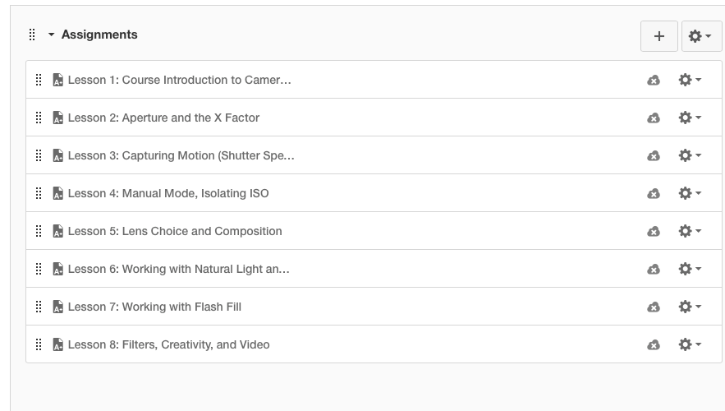



(Lesson 1 is the secondary lesson that will be attempted to complete for this assignment).

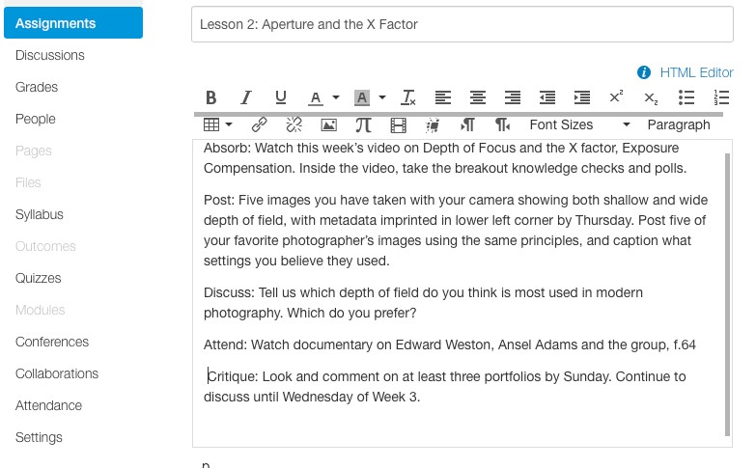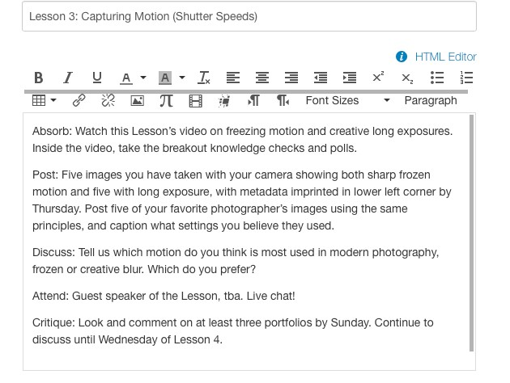

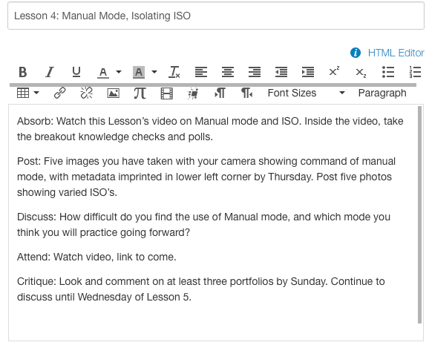

(Lesson 4 is the primary goal to complete for this assignment).







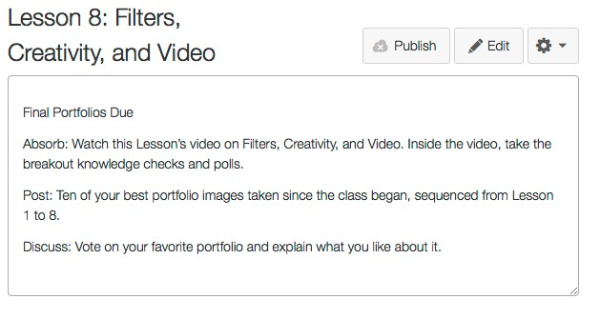

### LESSON 4 Storyboard

Though an attempt will be made to complete the Intro section, one workshop, one mock Live Chat, and a Pre-Assessment, Lesson 4 is the most important lesson in the course. Following is a partial storyboard:

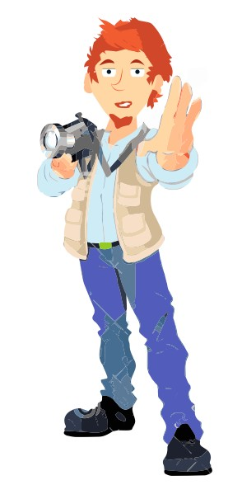

|  |  |  |
| --- | --- | --- |
| **ACTION** | **GRAPHICS** | **NARRATION** |
| Nik Canon, Animated Character, talking to camera (learner audience) | Adobe Character Animator | Welcome back to Week 4, creative interpreters of the world. You’re looking good. Today, we’re going to wean you off Auto modes and dive deep into our dials, gaining maximum creative control with manual exposure. Take back control of your camera, people. Make photography great again! |
| Dialing exposure in action, scene exposure reflects exposure | Exposure dial foreground, random scene background changing exposure. | To really impress, we will have to wean you off the X factor – exposure compensation. Exposure compensation is not some fourth dimension of exposure. Exposure compensation is only a way to override what your light meter is telling you. |
| Camera dial spins to Manual mode. | Manual Dial. | But if you want consistent photos, there’s only one way to fly, and that’s with Manual exposure. |
| Internet | Manual ASA | We’ll also talk about auto ASA in the digital world. Wait, did I say ASA or ISO? I must be graying whiskers. Time |

|  |  |  |
| --- | --- | --- |
|  |  | for a wiki history lesson! |
| Wood- stock archive photos. | Woodstock, Kodak Film. | Imagine you were a photographer at Woodstock. At that time, ASA, or American Standards Association, was a number locked to your film roll, of course invented by the American film company, Eastman Kodak. If you were to shoot in daylight, you would choose ASA 25-200 film, and if shooting at night or the shadows, 400- 3200 ASA film. |
|  | Joplin | We might find ourselves just a few frames exposed through a roll of kodachrome, ASA 50 in sunlight, and then be desiring to shoot Janis at night with ASA 800 film, but we still have this ASA 50 in our camera, so we would have to resort to flash, and lose the atmosphere of the event. |

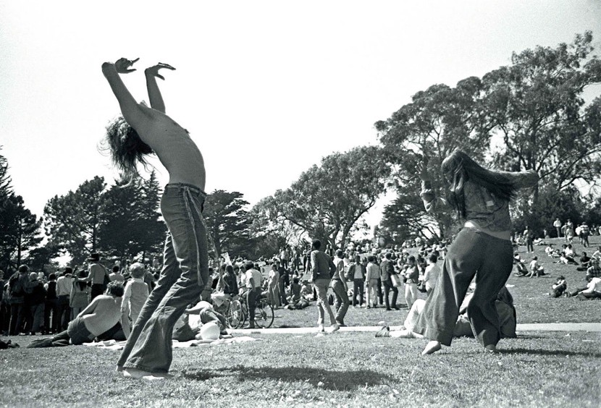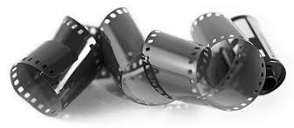

|  |  |  |
| --- | --- | --- |
|  | Woodstock hippies | Or we have to rip the film out halfway through. |
|  | Unraveled film. | What a waste of film! That’s what my old photography professor used to tell me every time I took a picture. Oh well. |
| Montage of film rolls from manufact urers | Nik with a german hat. Agfa Film in background. | All the way up until the 80’s ASA was the term proper, when along came other film roll producers like AGFA, a German manufacturer. The term International Standards Organization, or ISO, replaced the term ASA. But there is much more to it than acronyms. |

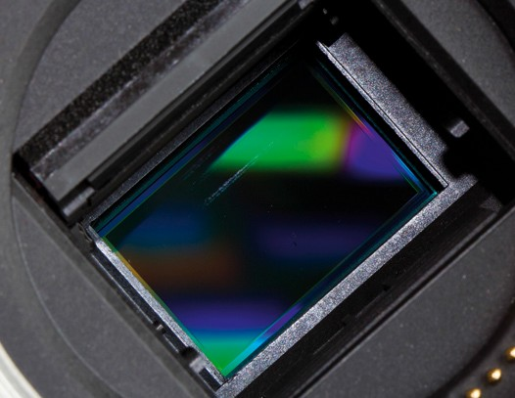

|  |  |  |
| --- | --- | --- |
| Nik |  | Digital cameras work like film, only the film is the sensor, which stores information in pixels on your memory card. It is the most costly piece of real estate on your camera. The ISO determines the level of sensitivity to light that this sensor reacts to, in the environment you expose it to. How that image sensor transfers RGB to pixels and writes it to your card is weird science, and you can follow some video links here… |
| Internet photo |  | But much like aperture, the more sensitive you dial that sensor up, the harder it works, producing noise. There’s no free lunch with ISO. But with even greater latitude than film, it allows you new freedoms that those film shooters never experienced. |

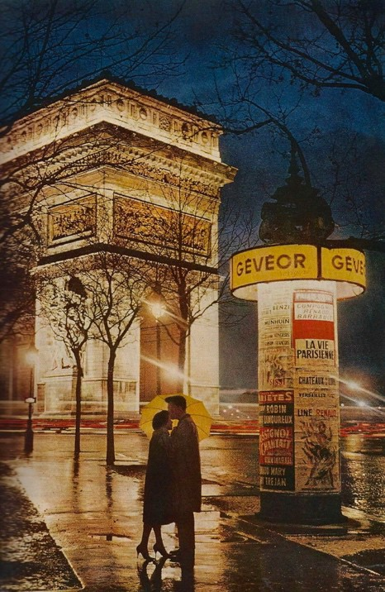

|  |  |  |
| --- | --- | --- |
| Side by side photos of film at 25 ISO and 3200 ISO.  Unknown Paris Photograp her |  | Some purists still shoot film, as raising the ISO  in film, can give you a lower ISO rating than a digital camera, producing very rich colors and impeccable resolution. Film still gives you an appealing grain effect at higher ISOs, adding to the richness of the image. |
|  |  | However, raising the ISO in digital will only give your image more noise.  Grain good, noise bad. But there’s good news behind all this. |

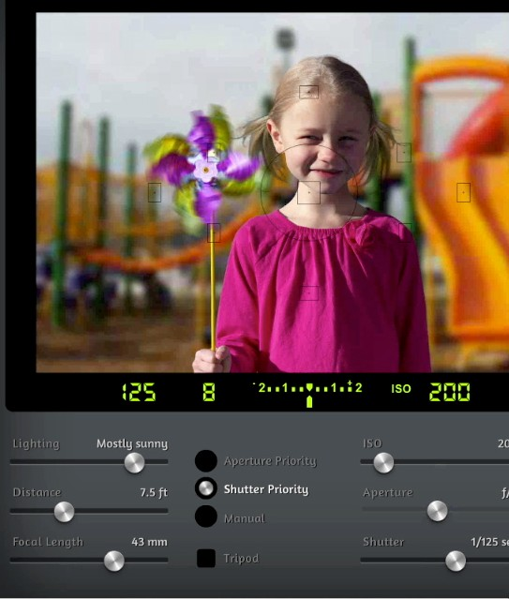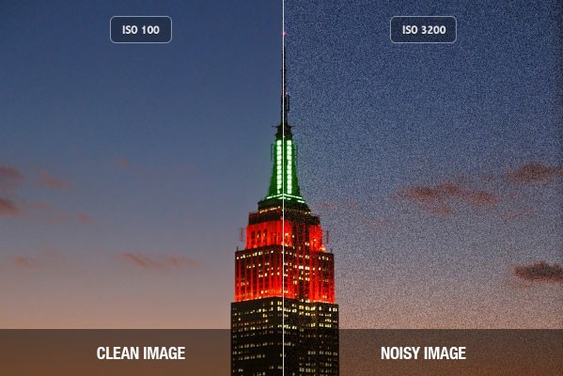

|  |  |  |
| --- | --- | --- |
| CIM  Simulator |  | Latitude, without changing film. With digital cameras, with increased sensitivity, your camera sensor can capture images in low- light environments without having to use a flash. But like I’ve pointed out, higher sensitivity comes at an expense – it adds grain or “noise” to the pictures. Yet, you will obtain a wider latitude of exposure through the ability to adjust your ISO and later on through RAW image processing. Let’s take a look at a few settings on our simulator here and how the ISO affects grain. |
| Illustratio n VO  Compariso n side by side photos, grain from film, noise from digital.  From Aperture. |  | And in this side by side comparison, it becomes more obvious that the ISO number you should optimally be shooting at is whatever is the base ISO on your camera, often ISO 100. ISO 200  means your sensor has doubled in sensitivity, 400, 800, 1600, you get the math. With a good camera, you won’t notice an increase in noise in the image until upwards of ISO 800 unless you are making large prints of your images; but as a purist, |

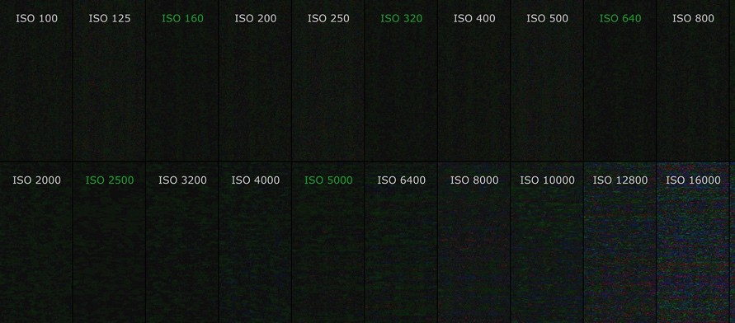

|  |  |  |
| --- | --- | --- |
|  |  | you will go for the tightest grain, the least noise. That’s right. ISO 100 or better as sensors improve. |
| Aperture |  | You may not notice the noise in a photo composed of white imagery, but set against a dark background, such as a night shot, when you would most likely want to pump up the ISO, whoa. Look at that ugly noise. |

|  |  |  |
| --- | --- | --- |
| Breakout Question | Side by side photos of varying ISO settings. | Question: Align the ISO number with each photo you think it was shot with. |
| Answer |  | Here you see the photos correctly arranged. You probably nailed that one, as it is fairly easy to see the difference in ISO captures when shot at night. |
| **Pinterest** | Comparison side by side photos, good camera, cheap camera.  Shots from both at low light. Image of grainy pancakes | Now we will compare the same ISO setting, with different models of cameras, simply to point out the advantages of an expensive pro digital camera, over the consumer model picked up at Best Buy or Costco. Just because the camera says it has an ISO of 50,000, does not mean that the image you capture will stack up to pancakes. |

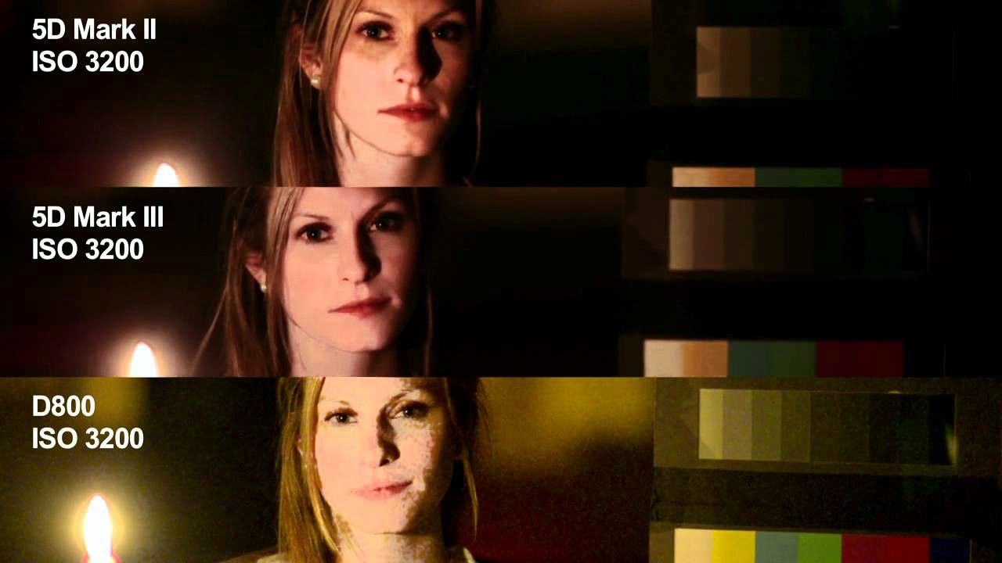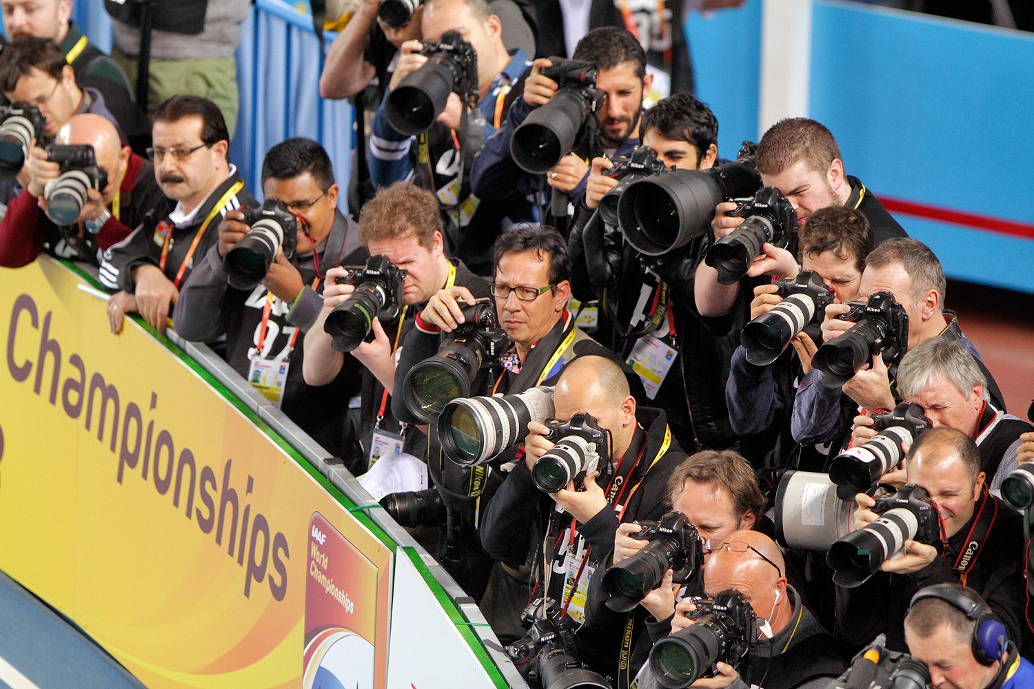

|  |  |  |
| --- | --- | --- |
| **Canon Manual** |  | With the prosumer camera, you will be relegated to shoot at an ISO of 800 or lower. You can shoot at a higher ISO, but you won’t be able to capture of a clean quality image free of distracting noise without the aid of a flash. |
| **Photo by Augusto Munoz.** |  | So now that we have discovered ISO, we can just go to Manual Mode, set our Aperture, set our Shutter Speed, throw ISO on Auto, and head for the photo pit, right? |
|  | Bad dog Otto. | Wrong. There’s that bad dog, Otto again. You would think that when set to auto ISO, in Manual mode, you can keep your lens at the same desired aperture, your shutter at the optimal shutter speed, and your camera makes the ISO adjustments for you.  Abracadabra! But this is just wishful thinking for the most part. You can experiment with this in dark environments, but I would recommend setting your maximum ISO in your menu settings to whatever your camera deems |

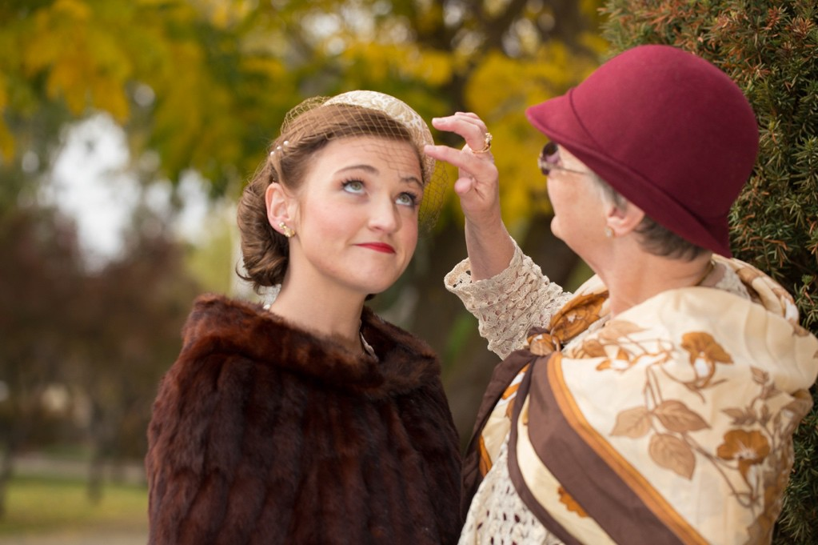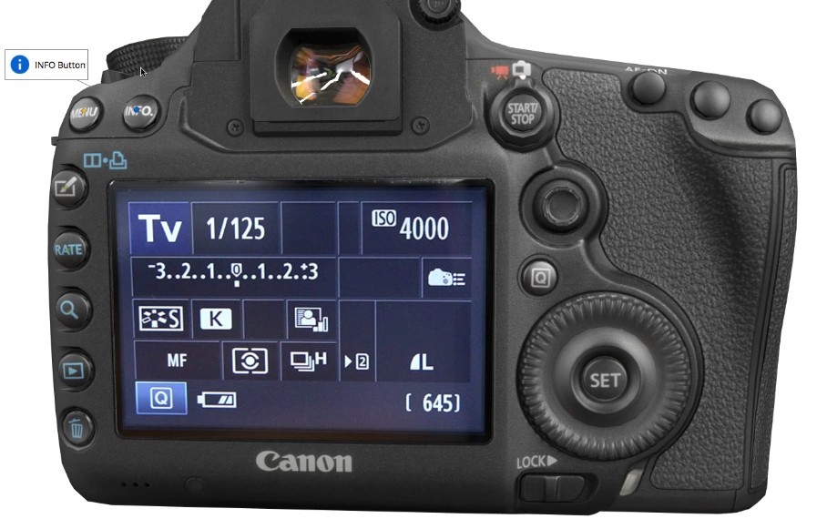

|  |  |  |
| --- | --- | --- |
|  |  | tolerable, say ISO 800- 1600. But as you’ve often heard me say, “Take control of your cameras, mates!” |
|  | Photographer’s hands setting the metering modes set to manual (to shoot). | So now that we’ve got that covered, and you’ve mortgaged your house, let’s get down to the most important thing you’ll learn in this course: Manual mode. With manual mode, you can set your exposure down to a science, taking all the guesswork out of photography. |
|  |  | Your compensation is going to be precise, and never shift on you. Adjust one or all of the three points: Aperture, Shutter Speed, ISO. Use the Golden triangle. |
|  |  | Now, instead of using exposure compensation, you will be looking at the light meter. If you’ve wondered what this thing is hanging around my neck, that’s a light meter, mate, old school. But you’re not going to worry about that. Use the one on your camera with the mysterious metering modes we’ll break down later. But with the one you’ve got, your exposure |

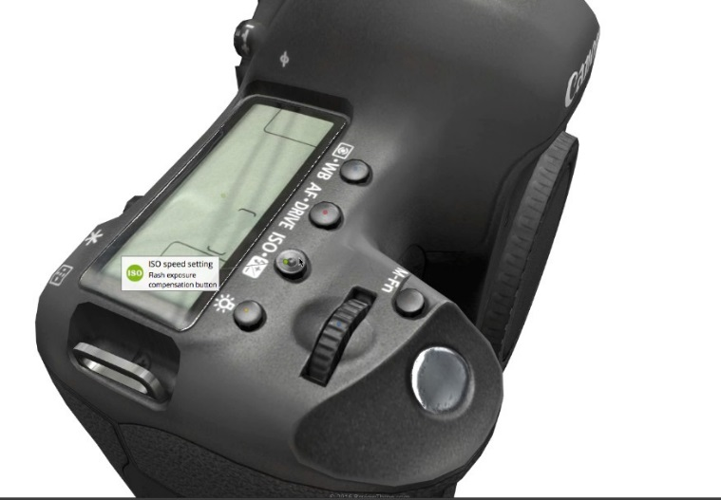

|  |  |  |
| --- | --- | --- |
|  |  | is going to be definite and absolute, not some guess by the tiny man inside the camera watching Tv. He might be taking the day off, or drank too much, of the sun of course. |
|  |  | Just be aware, that this is nothing like the priority or program modes. Take your thumb out of your mouth, it’s an entirely new beast altogether. Everyone has a different style of shooting. To each his own puppet.  But if you want to take complete control of your exposure, shoot manual. |
|  | Photographer adjusting the ISO (to shoot) | Here IS the magic. If you have a desire to shoot with both a greater depth of focus, and fast shutter speed, you will be able to adjust the ISO higher accordingly. |
|  |  | It’s all about using your light meter to balance out the three pillars of exposure, while creating the optimum look that juices your creativity.  Adjust one setting, and unless you adjust the lighting, you will be the master, and adjust another. Plain and simple as that. Take a shot. Too dark, too bright? Dial it in the way you envision, not the way your camera envisioned for you. |

|  |  |  |
| --- | --- | --- |
|  |  | Let’s take a look at a working example. The sun is behind your subjects, so your subjects are dark. You don’t have the option of moving the sun or the mountain, so Muhammed must adjust. To make things more difficult, the sun is going in and out of the clouds, you’re shooting in snow, with a Polarizer filter, so you’re going to have to open up at least two stops. Crikey mate!  Your camera is in full freak mode, and so are you.. |
|  | Skier in sunlight. Skier in shadows. | With film, you would be stuck shooting only in the sunlight. Whenever the skier goes into the shadows, you had no latitude, and unless you were sporting two cameras with two different ISOs, you were crocked. Even if you were opened all the way up, and lightning quick at adjusting your shutter speed, |

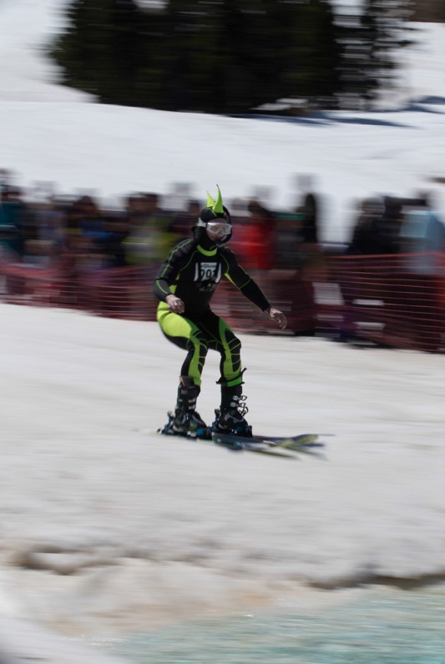

|  |  |  |
| --- | --- | --- |
|  |  |  |
|  | Speed pan skier shot. | you would have to be incredibly good at panning with the subject, which I hope one day you will be with practice. |
|  | Show metadata with shutter speed changing from 1/500 to 1/125 | Otherwise by adjusting your exposure with the X factor, exposure compensation, you would have dialed in a longer shutter speed, which reduce your ability to sharply freeze the subject. |

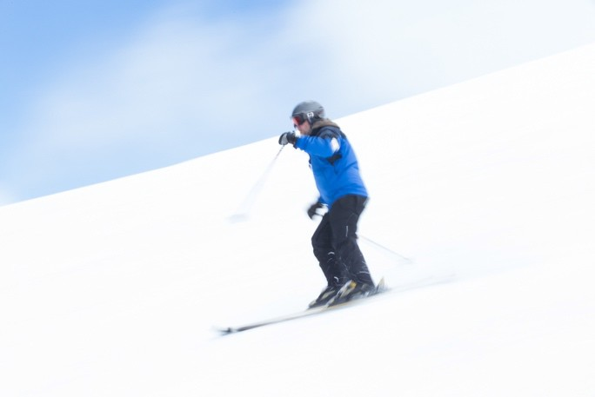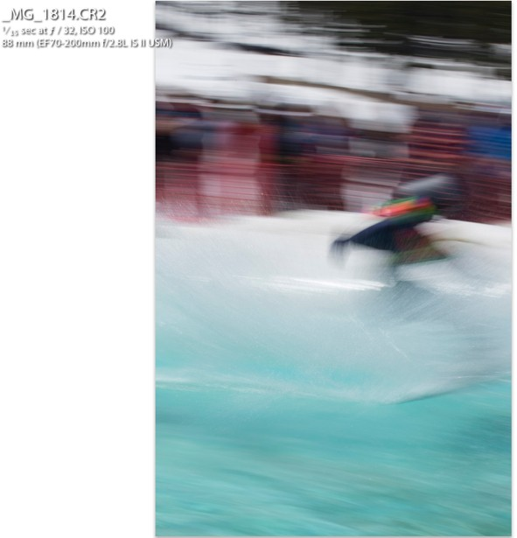

|  |  |  |
| --- | --- | --- |
|  |  |  |
|  | Blurry skier photos | Or worse yet, you start flipping your dials around to Aperture Priority, get your shots back from the photo lab a few days later, and take a look at the blurry bloody mess. Nooo! I was on F32! |
| Breakout Question |  | If you wanted to give yourself the best chances at capturing a fast moving image, which of the pillars would you adjust?   1. Higher ISO 2. Greater depth of field 3. Sharper shutter speed 4. All the above 5. B and C A and B |

|  |  |  |
| --- | --- | --- |
| Answer |  | f) D! So you see, it is much more difficult to see the difference when shooting against a brighter, busier scene. So take advantage of that. Shallow depth of field and frozen motion don’t go together. Push the ISO. Get the shot. |
|  | Nik |  |
|  | Rafters | When time is of the essence. When yes, you’re completely flustered. The sky is falling, a cow is jumping over the moon.  This is when it’s okay to be on either shutter priority or aperture priority mode.  That’s what the modes are there for. If you’re really in a panic, you have my permission. Go Auto! Just don’t tell the camera gods I told you to. Sometimes you may be shooting one thing, and then see something better out of the corner of your eye, and have no time to make adjustments, so throw it on Program or Auto. |

|  |  |  |
| --- | --- | --- |
|  |  | At all other times, you should practice with manual exposure. Put the guesswork in the drawer and shoot away on Manual mode, so that you can be just as quick on the draw, and get just the right exposure, spot on every time. And that’s what we’ll be exercising our dials on this week, Mates. |
| Breakout question | Question 3: You are trying to freeze the motion on this skier, and have some latitude in your focal range: Your ISO is at 100, your fstop is at 8 and your shutter speed at 1/500. The first image came out too dark, what would you adjust? | 1. My tripod. 2. My fStop 3. My ISO 4. I will put my ISO on auto and let the camera sort it out. |
|  | Answer to Question 2: ISO | You could put your ISO on auto, but may not achieve the desired results, especially in snow or bright water, where you will have to overexpose by at least one stop to compensate for your light meter going on vacation. Manually adjust your ISO to a higher number until you achieve optimal exposure. Voila!  You can really push these cameras further than film, further than yesterday’s model, further than ever before. |
|  | Assignment graphic | Your assignment for Lesson 4 is to present your best ten shots, all on manual.  We will have fun critiquing these next week. No pressure! Don’t forget to caption the metadata on |

|  |  |  |
| --- | --- | --- |
|  |  | the image.  4. |
|  | Nik in tie dye shirt. | Go forth and be creative! |
|  |  |  |

# Merrill’s 5 Star Instructional Design Rating Evaluation

## Type of Instruction:

|  |  |  |  |
| --- | --- | --- | --- |
| **Stage Criteria Explanation** | | | |
| **Rating for Problem Stage:** | | | |
| Is the courseware presented in the context of real world problems? | Does the courseware show Learners the task they will be able to do or the problem they will be able to solve as a result of completing a module or course? | | Yes. The course is designed for Learners that are overwhelmed with the amount of information and need guidance to provide them with the backbone for creativity.  The Critique and Discussions allow the Learners to engage at the program and task levels.  The course presents several layers of problems all designed to build upon photo fundamentals. |
| Are students engaged at the problem or task level not just the operation or action levels? | |
| Does the courseware involve a progression of problems rather than a single problem? | |
| **Rating for Activation Stage:** | | | |
| Does the courseware attempt to activate relevant prior knowledge or experience? | Do the courseware direct Learners to recall, relate, describe, or apply knowledge from relevant, past experience that can be used as a foundation for new knowledge? | Somewhat. The course recalls imagery that the learner has most likely viewed and admired throughout their life, yet did not know why they admired it.  Yes, the course provides fundamentals for the lifelong photographic learning experience. | |
| Does the courseware provide relevant experience that can be used as a foundation for the new knowledge? |

|  |  |  |
| --- | --- | --- |
| **Stage** | **Criteria** | **Explanation** |
|  | If Learners already know some of the content are they given an opportunity to demonstrate their previously acquired knowledge or skill? | Yes because the course is designed to allow the Learner to go to just the sections they want to learn more about or take the entire course. But to become immersed in the class, they should take the course in progression. |
| **Rating for Demonstration Stage:** | | |
| Are the demonstrations (examples) consistent with the content being taught? | Are the demonstrations (examples) consistent with the content being taught?   * Examples and non-examples for concepts? * Demonstrations for procedures? * Visualizations for processes? * Modeling for behavior? | Yes, the course uses photography to teach photography. It utilizes both good and bad examples of photography. Learners are provided additional resources and relevant demonstrations by professionals. Yes, 3D visualizations of cameras and a camera exposure simulator. Examples of great photos are used for modeling. |
| Are at least some of the following Learner guidance techniques employed?   * Learners are directed to relevant information? * Multiple representations are used for the demonstrations? * Multiple demonstrations are explicitly compared? |
| Is media relevant to the content and used to enhance learning? | Yes. Photography examples, YouTube videos, graphics, simulations are all used for examples and to break up the info-dump aspect. Professor Cannon keeps it fun and happy. Edutainment hopefully at its best. |
| **Rating for Application Stage:** | | |
| Are the application (practice) and the posttest consistent with the stated or implied objectives? | Are the application (practice) and the posttest consistent with the stated or implied objectives?   * Information-about practice requires Learners to recall or recognize information. * Parts-of practice requires the Learners to locate, name, and/or describe each part. * Kinds-of practice requires Learners to identify new | There is no post test. The post test is the portfolio. Portfolios are judged on transferring information learned in lessons to actual photographs taken by the learners.  There is really no scaffolding involved. Links stay up and discussions add more links to more resources. At the same time, the course keeps to a consistent volume of information as to not overburden the learner. |

|  |  |  |
| --- | --- | --- |
| **Stage** | **Criteria** | **Explanation** |
|  | examples of each kind.   * How-to practice requires Learners to do the procedure. * What-happens practice requires Learners to predict a consequence of a process given conditions, or to find faulted conditions given an unexpected consequence. |  |
| Does the courseware require Learners to use new knowledge or skill to solve a varied sequence of problems and do Learners receive corrective feedback on their performance? |
| In most application or practice activities, are Learners able to access context sensitive help or guidance when having difficulty with the instructional materials? Is this coaching gradually diminished as the instruction progresses? |
| **Rating for Integration Stage:** | | |
| Does the courseware provide techniques that encourage Learners to integrate (transfer) the new knowledge or skill into their everyday life? | Does the courseware provide an opportunity for Learners to publicly demonstrate their new knowledge or skill? | Not during the course, but afterwards they can attempt to be published in locally.  Discussion boards provide reflection, discussion, and defense of new knowledge.  As lifelong learners, the connections made during the course could potentially form groups to further support each other in their photographic pursuits. |
| Does the courseware provide an opportunity for Learners to reflect-on, discuss, and defend their new knowledge or skill? |
| Does the courseware provide an opportunity for Learners to create, invent, or explore new and personal ways to use their new knowledge or skill? |

### Assessment Examples

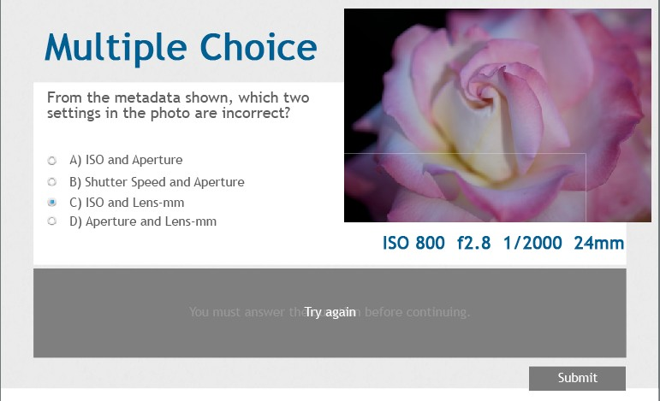

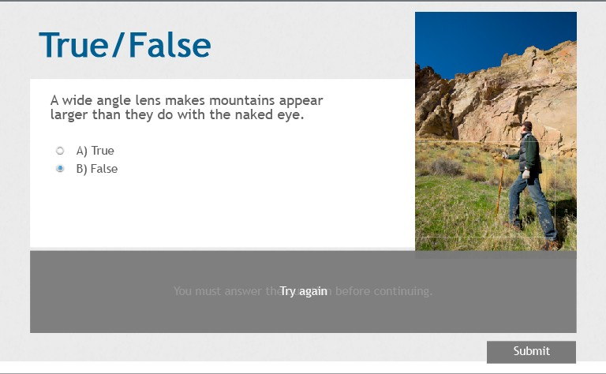

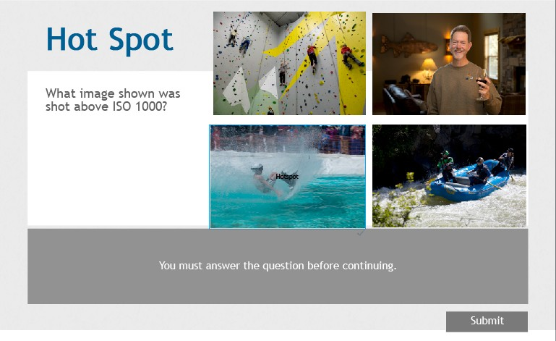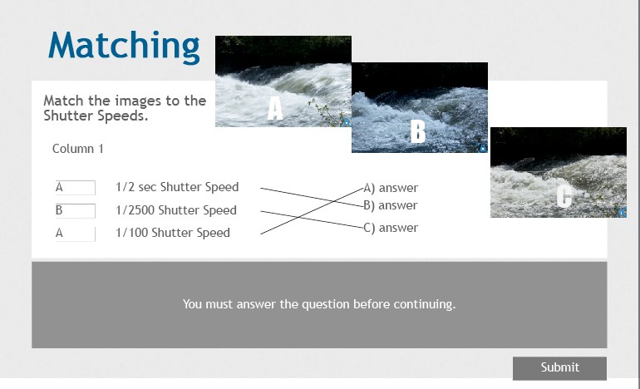

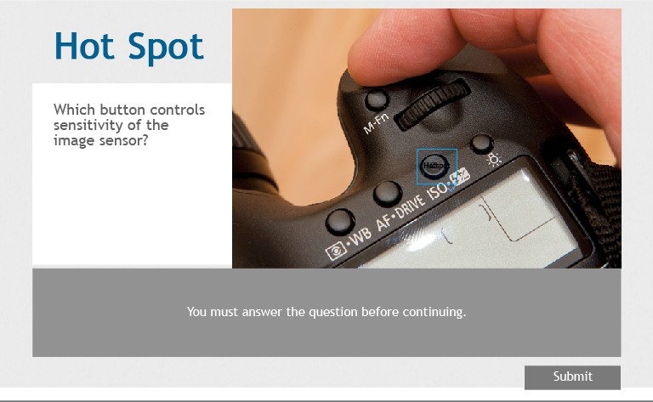

# Bibliography

Horton, W. (2012). *E-Learning by Design, 2nd Edition.* San Francisco, CA: Pfeiffer. Merrill, M. D. (2001, April 27). 5 Star Instructional Design Rating. Utah, US. Photographic examples by Jonathan Weston unless otherwise stated.